**A**

**PROJECT REPORT**

**ON**

**“ATTENDANCE SYSTEM USING FACE RECOGNITION”**

**SUBMITTED TO**

**SHIVAJI UNIVERSITY, KOLHAPUR**

**IN THE PARTIAL FULFILLMENT OF REQUIREMENT FOR THE AWARD OF DEGREE BACHELOR OF ENGINEERING IN COMPUTER SCIENCE AND ENGINEERING**

**SUBMITTED BY**

**MISS. Prerna Rathi 19UCS109**

**MR. Praveen Sathe 19UCS114**

**MR. Anand Satpute 19UCS115**

**MR. Anubhav Singh 19UCS125**

**MISS. Mansi Sogani 19UCS126**

UNDER THE GUIDANCE OF

**Prof. T. I. Bagban**



**DEPARTMENT OF COMPUTER SCIENCE AND ENGINEERING**

**DKTE SOCIETY’S TEXTILE AND ENGINEERING INSTITUTE, ICHALKARANJI**

**2022-2023**

**D.K.T.E. SOCIETY’S**

**TEXTILE AND ENGINEERING INSTITUTE, ICHALKARANJI**

**(AN AUTONOUMOUS INSTITUTE)**

**DEPARTMENT OF COMPUTER SCIENCE & ENGINEERING**



**CERTIFICATE**

**This is to certify that, project work entitled**

**“Attendance System Using Face Recognition”**

**is a bonafide record of project work carried out in this college by**

**MISS. Prerna Rathi 19UCS109**

**MR. Praveen Sathe 19UCS114**

**MR. Anand Satpute 19UCS115**

**MR. Anubhav Singh 19UCS125**

**MISS. Mansi Sogani 19UCS126**

**is in the partial fulfillment of award of degree bachelor’s in engineering in Computer Science & Engineering prescribed by Shivaji University, Kolhapur for the academic year 2022-2023.**

**Prof. T.I. Bagban**

**(PROJECT GUIDE)**

**PROF.(DR.) D.V. KODAVADE PROF.(DR.) Mrs. L.S. ADMUTHE**

**(HOD CSE DEPT.) (DIRECTOR)**

**EXAMINER:** ______________________

**DECLARATION**

We hereby declare that the project work report entitled “Attendance System Using Face Recognition” which is being submitted to D.K.T.E. Society’s Textile and Engineering Institute Ichalkaranji, affiliated to Shivaji University, Kolhapur is in partial fulfillment of degree B.E.(CSE). It is a bonafide report of the work carried out by us. The material contained in this report has not been submitted to any university or institution for the award of any degree. Further, we declare that we have not violated any of the provisions under Copyright and Piracy / Cyber / IPR Act amended from time to time.

Name Prn Signature

**MISS. Prerna Rathi 19UCS109**

**MR. Praveen Sathe 19UCS114**

**MR. Anand Satpute 19UCS115**

**MR. Anubhav Singh 19UCS125**

**MISS. Mansi Sogani 19UCS126**

**ACKNOWLEDGMENT**

With great pleasure we wish to express our deep sense of gratitude to Prof. T. I. Bagban for his valuable guidance, support, and encouragement in the completion of this project report.

Also, we would like to take the opportunity to thank our head of department Dr. D. V. Kodavade for his co-operation in preparing this project report.

We feel gratified to record our cordial thanks to other staff members of the Computer Science and Engineering Department for their support, help and assistance which they extended as and when required.

Thank You,

MISS. Prerna Rathi 19UCS109

MR. Praveen Sathe 19UCS114

MR. Anand Satpute 19UCS115

MR. Anubhav Singh 19UCS125

MISS. Mansi Sogani 19UCS126

**ABSTRACT**

In recent years, the development and integration of biometric technologies have revolutionized various domains, including attendance management systems. This paper presents an innovative approach to attendance tracking by leveraging the power of face recognition technology. The proposed system aims to automate the traditional manual attendance marking process, eliminating the need for time-consuming paperwork, and reducing human errors.

The attendance system employs state-of-the-art deep learning algorithms to recognize and verify individuals based on their facial features. By capturing and analyzing facial images, the system identifies unique facial patterns and matches them against a pre-registered database, enabling accurate and efficient attendance management. This technology offers numerous advantages, such as increased security, enhanced privacy, and improved convenience for both students and faculty.

The system's architecture consists of three main components: face detection, face recognition, and attendance management. The face detection module utilizes advanced computer vision techniques to locate and extract faces from the input images or video streams. Once the faces are detected, the face recognition module applies deep neural networks to extract and encode distinctive facial features, enabling reliable identification and authentication.

To ensure robustness and adaptability, the system undergoes a rigorous training phase using a large dataset of labeled facial images. This training enables the system to learn and generalize facial features, allowing it to accurately recognize individuals under various lighting conditions, poses, and facial expressions. Additionally, the system employs data encryption and strict privacy protocols to protect sensitive personal information, ensuring compliance with privacy regulations.

The attendance management component provides a user-friendly interface for administrators to monitor and manage attendance records. It offers real-time attendance tracking, generating accurate reports, and alerts for late or absent students. Furthermore, the system can be integrated with existing school management systems, providing seamless data synchronization, and reducing administrative overhead.

To evaluate the performance of the proposed system, extensive experiments were conducted using a diverse dataset. The results demonstrated high accuracy and efficiency in attendance tracking, outperforming traditional methods. The system's performance was also evaluated in terms of speed, scalability, and robustness, showcasing its suitability for deployment in various educational institutions.

In conclusion, the attendance system presented in this paper harnesses the power of face recognition technology to automate and streamline attendance management processes. By leveraging advanced deep learning algorithms, the system offers improved accuracy, security, and convenience compared to conventional methods. The integration of this system in educational institutions has the potential to enhance efficiency, reduce administrative burden, and promote a more productive learning environment.

Index

1. Introduction 1
   1. Problem Definition 2
   2. Aim and objectives 3
   3. Scope and limitations 4
   4. Project Timeline 5
   5. Project Management Plan 6
   6. Project Cost 7
2. Background Study and Literature Overview 8
   1. Literature Overview 9
   2. Critical appraisal of existing research and projects 9
   3. Investigation of current project and related work 10
3. Requirement Analysis 11
   1. Requirement Gathering 12
   2. Requirement Specification 13
   3. Use Case Diagram 14
4. System Design 15
   1. Architectural Design 16
   2. User Interface......………………………………………….........…17
   3. Algorithm 18
   4. System Modeling 21
      1. Dataflow Diagram 22
      2. Component Diagram 23
      3. Sequence Diagram 24
      4. Activity Diagram 25
5. Implementation 26
   1. Environmental Settings 27
   2. Detailed Description of Methods 27
   3. Implementation details 29
6. Integration and Testing 30
   1. Description of the Integration Modules 31
   2. Testing 32
7. Future Scope 33
8. Applications 35
9. Installation Guide and User Manual 38
   1. Installation Guide 39

9.2 User Manual 40

1. Plagiarism Report 41
2. Ethics 43
3. References 46

**Chapter 1**

**Introduction**

D.K.T.E Society’s Textile and Engineering Institute, Ichalkaranji

D.K.T.E Society’s Textile and Engineering Institute, Ichalkaranji

**Introduction**

The use of facial recognition technology has gained significant attention and popularity in various fields, including security, biometrics, and identification systems. One prominent application of facial recognition technology is in attendance systems, where it offers a more convenient and efficient alternative to traditional methods of recording attendance. By leveraging the unique characteristics of individuals' faces, attendance systems using facial recognition provide an automated and reliable means of accurately tracking and monitoring attendance in various settings, such as educational institutions, workplaces, and events.

The traditional attendance systems, such as paper-based sign-in sheets or swipe cards, are not only time-consuming but also prone to errors and manipulation. Additionally, these methods may not be suitable for scenarios where a large number of individuals need to be recorded quickly and accurately. This is where facial recognition-based attendance systems offer a significant advantage. By utilizing advanced computer vision algorithms, these systems can identify and verify individuals based on their facial features with remarkable speed and accuracy.

The core principle behind a facial recognition-based attendance system involves capturing an individual's facial image using a camera or webcam, extracting unique facial features, and comparing them against pre-registered data. The system utilizes complex algorithms to analyse facial patterns, such as the arrangement of eyes, nose, mouth, and other distinctive facial landmarks. By comparing these patterns with the stored data, the system can accurately identify and authenticate individuals in real-time.

The benefits of using facial recognition technology for attendance management are numerous. Firstly, it eliminates the need for physical cards, badges, or passwords, streamlining the attendance process and reducing the chances of fraudulent activities such as buddy punching. Secondly, it offers enhanced security by ensuring that only authorized individuals gain access to specific areas or resources. Thirdly, facial recognition-based attendance systems provide real-time tracking and reporting, allowing administrators to monitor attendance patterns, generate attendance reports, and analyse attendance data effortlessly.

However, it is essential to address potential concerns regarding privacy and data security when implementing facial recognition-based attendance systems. Organizations must adhere to applicable laws and regulations regarding the collection, storage, and usage of biometric data. It is crucial to implement robust security measures to safeguard the collected facial data and ensure that it is used solely for attendance purposes.

In conclusion, attendance systems utilizing facial recognition technology have revolutionized the way attendance is recorded and managed. With their speed, accuracy, and convenience, these systems offer an effective solution for organizations seeking to streamline attendance tracking, enhance security, and improve overall efficiency. As technology continues to advance, the potential applications and benefits of facial recognition-based attendance systems are expected to grow, making them an increasingly popular choice for organizations across various sectors

* 1. **Problem Definition**

The existing manual attendance systems used in various organizations, such as schools, universities, and workplaces, are often time-consuming, prone to errors, and lack efficiency. To overcome these challenges and improve the accuracy and convenience of attendance tracking, an automated attendance system using face recognition technology is proposed.

The problem is that the current manual attendance systems rely on methods like paper-based sign-in sheets or manual entry into electronic systems, which can be easily manipulated or prone to errors. These methods are also inefficient and require significant administrative effort to maintain and analyze attendance records.

The proposed solution aims to leverage the advancements in face recognition technology to create a robust and accurate attendance system. By using facial recognition algorithms and techniques, the system will be able to identify individuals and match their faces with stored data, eliminating the need for manual entry and reducing the risk of false attendance.

**Key Objectives:**

* **Accuracy:** Develop a system that can accurately recognize individuals based on their facial features, ensuring reliable attendance tracking.
* **Efficiency:** Create an automated system that eliminates the need for manual sign-in processes, reducing administrative effort and saving time.
* **Security:** Implement robust security measures to protect the privacy and integrity of the attendance data, ensuring that only authorized personnel can access the system.
* **Scalability:** Design a system that can handle many users simultaneously, accommodating organizations of various sizes and attendance requirements.
* **Integration:** Ensure seamless integration with existing attendance management systems or provide a comprehensive standalone solution.
* **User-Friendly Interface:** Develop an intuitive and user-friendly interface that allows both administrators and attendees to easily interact with the system.
* **Reporting and Analytics:** Provide comprehensive attendance reports and analytics for administrators to gain insights and make informed decisions.

**1.2 Aim and Objectives**

**Aim:**

To implement an attendance system using face recognition for a given set of students in a classroom.

**Objectives:**

1. Accurate Face Identification: Develop a robust system capable of accurately identifying student faces.
2. Automated Attendance Marking: Automatically mark attendance based on face recognition, eliminating the need for manual processes.
3. Time and Effort Reduction: Reduce the time and effort required for manual attendance tracking, benefiting both teachers and students.
4. Improved System Efficiency: Provide a valuable attendance system that enhances flexibility and minimizes time loss.
5. Prevention of Proxy Attendance: Ensure the system eliminates the possibility of proxy attendance, enhancing attendance accuracy and accountability.

Expected achievements in order to fulfill the objectives are:

1. Face Segmentation: Successfully detect and segment the face region from video frames.
2. Feature Extraction: Extract relevant and useful features from the detected faces for accurate recognition.
3. Face Classification: Develop a classification system to accurately recognize and identify the detected faces.
4. Attendance Recording: Implement a system to record the attendance of identified students reliably and efficiently.

By achieving these objectives and expected outcomes, the face recognition-based automated student attendance system will significantly improve the accuracy, efficiency, and convenience of attendance tracking while preventing proxy attendance and reducing manual efforts for both teachers and students.

**1.3 Scope and Limitations**

Attendance management system keeps track of daily attendance, working hours, breaks, login, and logout time. It prevents staff's time theft. An attendance management system integrates all attendance devices such as smart cards, biometric, and facial recognition devices in real-time. The student attendance system allows you to record & manage daily student attendance to speed up the daily attendance process.

**Limitations:**

1. Accuracy Constraints: While face recognition technology has significantly improved, there may still be instances where accuracy can be affected due to factors like lighting conditions, occlusions, or changes in appearance (e.g., wearing glasses, makeup, facial hair).
2. Hardware and Infrastructure Requirements: The system may require dedicated hardware, such as cameras to capture video frames for face recognition.
3. Enrollment and Database Management: The system will rely on a pre-enrolled database of student (50 images per student) faces for recognition, which may require periodic updates to include new students or handle changes in appearance. Proper database management and maintenance are essential for accurate recognition.
4. Privacy and Security Concerns: As the system involves capturing and processing facial data, strict measures need to be implemented to protect the privacy and security of the collected information.
5. Environmental Factors: Environmental conditions, such as poor lighting or crowded spaces, may impact the system's performance and accuracy. Adequate measures should be taken to mitigate these factors.
6. User Cooperation and Acceptance: The accuracy of face recognition depends on the willingness of individuals to cooperate by presenting their faces properly and consistently. User acceptance and understanding of the system are crucial for its successful implementation.

**1.4 Timeline of Project**

The project commenced in July 2022 with document gathering and requirements analysis, completed by mid-August. By November 2022, system design, including UML diagrams and a project synopsis, was finalized. During November and December 2022, the detailed SRS document was developed, and the project methodology was chosen.

In January 2023, coding began, divided into two modules. The first module was completed by the end of January, and the second module was finished by March. Testing and GUI design were conducted in parallel, concluding in early April 2023. The project progressed through crucial stages, including document gathering, analysis, system design, SRS development, coding, testing, and GUI design, adhering to a well-defined timeline.

Overall, the project timeline spans from July 2022 to April 2023, with initial phases focusing on gathering requirements and conducting analysis. System design, SRS development, and methodology selection followed suit. Coding took place in early 2023, divided into two modules, with testing and GUI design conducted alongside. By April 2023, the project had successfully reached major milestones, positioning it for further development and implementation.

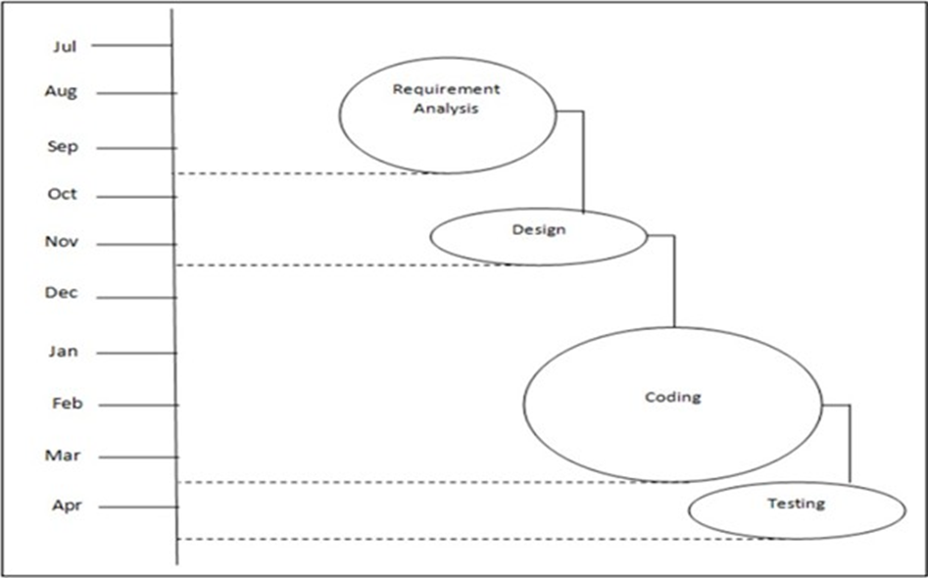

**1.5 Project Management Plan**

|  |  |  |  |  |
| --- | --- | --- | --- | --- |
| **Task** | **Period** | **Start Time** | **End Time** | **Priority** |
| Domain Selection | 7 days | 15-07-2022 | 22-07-2022 | High |
| Analysis of various problems suitable in the selected domain | 15 days | 23-07-2022 | 07-08-2022 | High |
| Domain finalization | 10 days | 08-08-2022 | 18-08-2022 | Medium |
| Problem detected | 7 days | 19-08-2022 | 26-08-2022 | High |
| Research on various problem statements detected | 10 days | 27-08-2022 | 05-09-2022 | Medium |
| Problem statement Finalize | 14 days | 06-09-2022 | 19-09-2022 | Medium |
| Study of research papers | 20 days | 20-09-2022 | 09-10-2022 | High |
| Synopsis Documentation | 15 days | 10-10-2022 | 24-10-2022 | High |
| Requirement Collection | 10 days | 25-10-2022 | 03-11-2022 | High |
| Module identification | 10 days | 04-11-2022 | 13-11-2022 | Medium |
| SRS documentation Presentation | 14 days | 14-11-2022 | 28-11-2022 | Medium |
| Collecting datasets | 10 days | 28-11-2022 | 08-12-2022 | High |
| Study various algorithm | 10 days | 08-12-2022 | 18-12-2022 | High |
| Code Implementation 30% | 25 days | 19-12-2022 | 14-01-2023 | High |
| Code Implementation 70% | 30 days | 15-01-2023 | 15-02-2023 | High |
| Testing and accuracy improvements | 20 days | 16-02-2023 | 06-03-2023 | High |
| Code updating | 10 days | 07-03-2023 | 17-03-2023 | High |
| Coding 90% | 20 days | 18-03-2023 | 08-04-2023 | High |
| Testing and Implementation | 8 days | 09-04-2023 | 13-04-2023 | High |

**1.6 Project Costing**

|  |  |  |
| --- | --- | --- |
| **Sr. No.** | **Required Hardware/ Software** | **Cost** |
| 1 | Computer system with i7 11th generation or above. | 50000 |
| 2 | Webcam | 2195 |
| 3 | 8GB or above RAM | 5000 |
| 4 | Python IDE to run machine learning modules. | 0 |

Estimated cost by considering other factors will be approximately – RS 57,195/-

**Chapter 2**

**Background Study and Literature Overview**

**2.1 Literature Overview**

In the face detection and recognition system, the process flow is initiated by being able to detect the facial features from a camera or a picture store in a memory. The algorithm processes the image captured and identifies the number of faces in the image by analyzing from the learned pattern and compare them to filter out the rest. This image processing uses multiple algorithm that takes facial features and compare them with known database. The motivation behind this project is to simplify how attendance is taken during lectures and how much time it takes. The use of ID cards or manually calling out attendance and writing it down on sheets is not productive and efficient. This system will detect the number of faces on the class and will also identify them from the store database. With the face detection and recognition system in place, it will be easy to tell if a student is present in the classroom or not.

**2.2 Critical appraisal of other people’s work:**

1. Semiautomated Class Attendance Monitoring Using Smartphone Technology

Summary:

The method used here is deep neural networks. The accuracy is also considerably high. The performance of the prototype was not accurate enough to use as is, but with some adjustments, it can become an inexpensive solution to the attendance recording problem. These adjustments may be taking more photos of the class, breaking the class up into smaller groups, taking a video, fine tuning the algorithms, or training them with more relevant data, obtaining more training images per student, or varying pose and angle.

Limitation:

To train the deep neural network models, one has to train the dataset with a lot of images for feature extraction which is time consuming. A lot of memory is also consumed to store a huge number of images as training dataset. It is extremely expensive to train due to complex data models.

1. The process of facial recognition with the Haar Cascade and Eigenface method can detect and recognize the face both during the day and night (with good light) as shown in the test results. Although the type of detection is for straight faces (frontal faces), it is still able to detect the face when it is facing to the side until about 15(degrees).

Limitation:

This method is suitable for face detection rather than identification. They tend to be prone to false-positive detections, require parameter tuning and are also not as accurate as the more modern documents that we have today. Followed by the optimization of the facial recognition process for use on a small mobile device. So, a one-shot algorithm with Siamese neural network is used which overcomes all the limitations of the above papers.

* 1. **Investigation of current project and related work**

**Survey of existing works**

As we analyzed these research papers and got the major idea that most of them used CNN as their technology. Some of them had limitations and some of them had a proper approach. Authors in this proposed a method to automate the attendance system by integrating the face recognition technology using Eigen face database and Principal Component Analysis (PCA) algorithm with MATLAB GUI. The architecture of the system first captures the student image, pre- processes it, applies an Eigenface generated database, then tests the captured face image with the Eigenface image. When the similarity distance test scored more than the threshold value of 0.3 then the face was not recognized. Finally, attendance marking was stored in a Microsoft Excel sheet integrated with the MATLAB GUI. The original face database consists of images for 15 persons each has 10 images with different position and direction.

The existing system has implemented a classroom attendance system using radio frequency identification (RFID) and face verification techniques. The system recognizes students by using the RFID card and for more confirmation of the student's identity, a face recognition technique has been added using Fast Adaptive Neural Network Classifier (FANNC).

The classifier was trained and tested to identify human face images. Every student needs to take seven dissimilar head poses images for the classifier to identify students' images. The facial system tested on six distinct images of students.

**Proposed System**:

All the students of the class must be registered by entering the required details and then their images will be captured and stored in the dataset. During each session, faces will be detected from live streaming video of the classroom. The faces detected will be compared with images present in the dataset. If a match is found, attendance will be marked for the respective student. The task of the proposed system is to capture the images of each student and to store it in the database for their attendance. The face of the student needs to be captured in such a manner that all the features of the students' face needs to be detected, even the seating and the posture of the student need to be recognized. There is no need for the teacher to manually take attendance in the class because the system records a video and through further processing steps the face is being recognized and the attendance database is updated.

**Chapter 3**

**Requirement Analysis**

* 1. **Requirement Gathering**

**Teacher (User)**

* 1. As a user, I want to register new students.
  2. As a user, I should be able to capture student images appropriately.
  3. As a user, I should receive any error messages in case an error occurs.
  4. As a user, I should see the student’s name and student id on identification.
  5. As a user, I should be able to view and edit the attendance sheet both previous and current.

**Non-functional requirement**

Non-Functional Requirements are the characteristics or attributes of the system that are necessary for the smooth operation of the system.

Those requirements are listed below.

* The system should perform the process accurately and precisely to avoid problems.
* The system should be easy to modify for any updates. Any errors or bugs that are identified should be easy to mend.
* The system should be secure and maintain the privacy of the students.
* The system should be easy to understand and use.
* Execution of the operation should be fast.

**3.2 Requirement Specification**

|  |  |  |  |  |
| --- | --- | --- | --- | --- |
| **Sr. No** | **Requirements** | **Essential/ Desirable** | **Description of requirements** | **Remark** |
| RS1 | The system must | Essential | The student | Database |
|  | be able to |  | information | should be |
|  | register students |  | entered by the | updated. |
|  |  |  | teacher should be |  |
|  |  |  | stored in the |  |
|  |  |  | database |  |
|  |  |  | efficiently. |  |
| RS2 | The system must | Essential | The student | The student |
|  | be able to |  | images captured | should be |
|  | capture student |  | by the user must | close |
|  | images |  | be stored in | enough |
|  |  |  | respective folders. | from the |
|  |  |  |  | camera. |
| RS3 | The system | Essential | The system | Error |
|  | should be able to |  | generates error | messages |
|  | generate error |  | messages if the | must be |
|  | messages |  | image is not | generated. |
|  |  |  | captured correctly. |  |

|  |  |  |  |  |
| --- | --- | --- | --- | --- |
| RS4 | The system must be able to detect students' faces correctly. | Essential | After detecting the student the system displays a face frame. | Frame is displayed after PCA. |
| RS5 | The system must be able to display student name and id | Essential | After identifying the student the system displays the student name and id. | student name and id are displayed appropriatel y. |
| RS6 | The system must be able to record student attendance correctly. | Essential | After the whole process, the system should generate an attendance sheet in real time. | Attendance sheet should be generated and displayed. |

* 1. **Use Case Diagram**

**Chapter 4**

**System Design**

* 1. **Architecture Design**

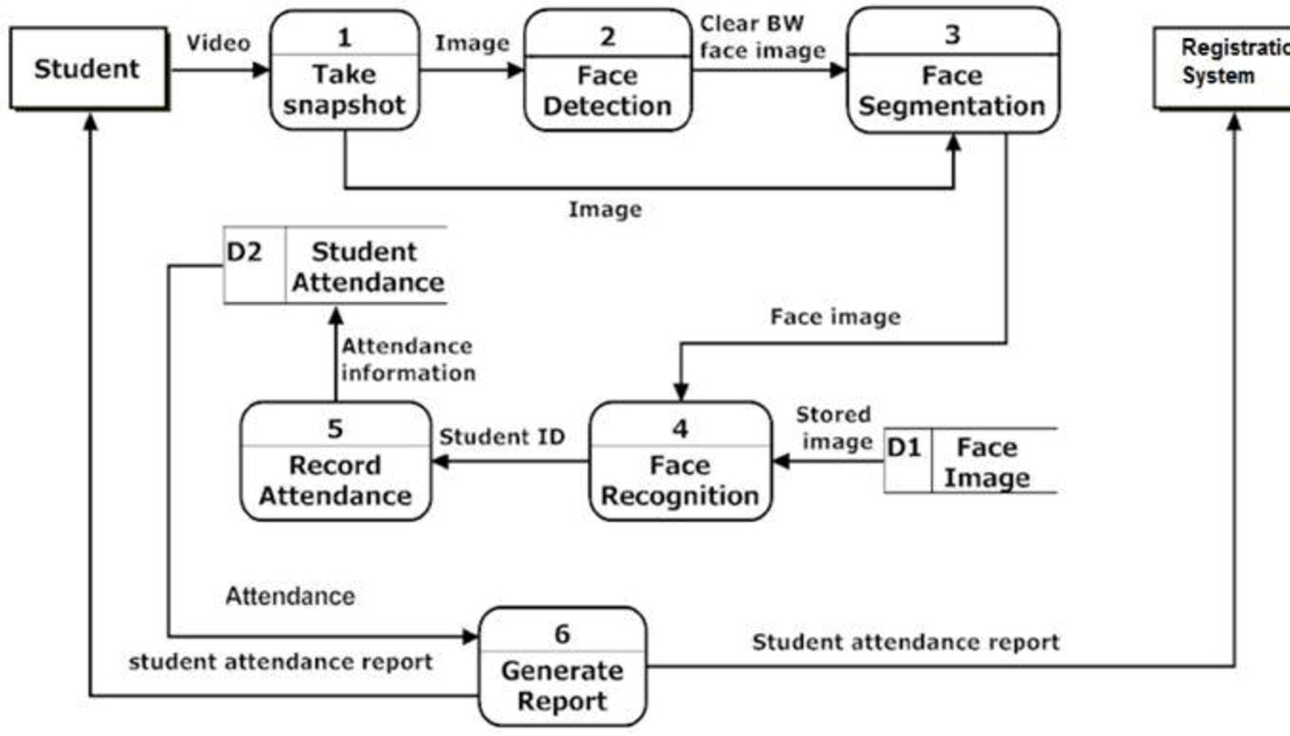

* 1. **User Interface Design**

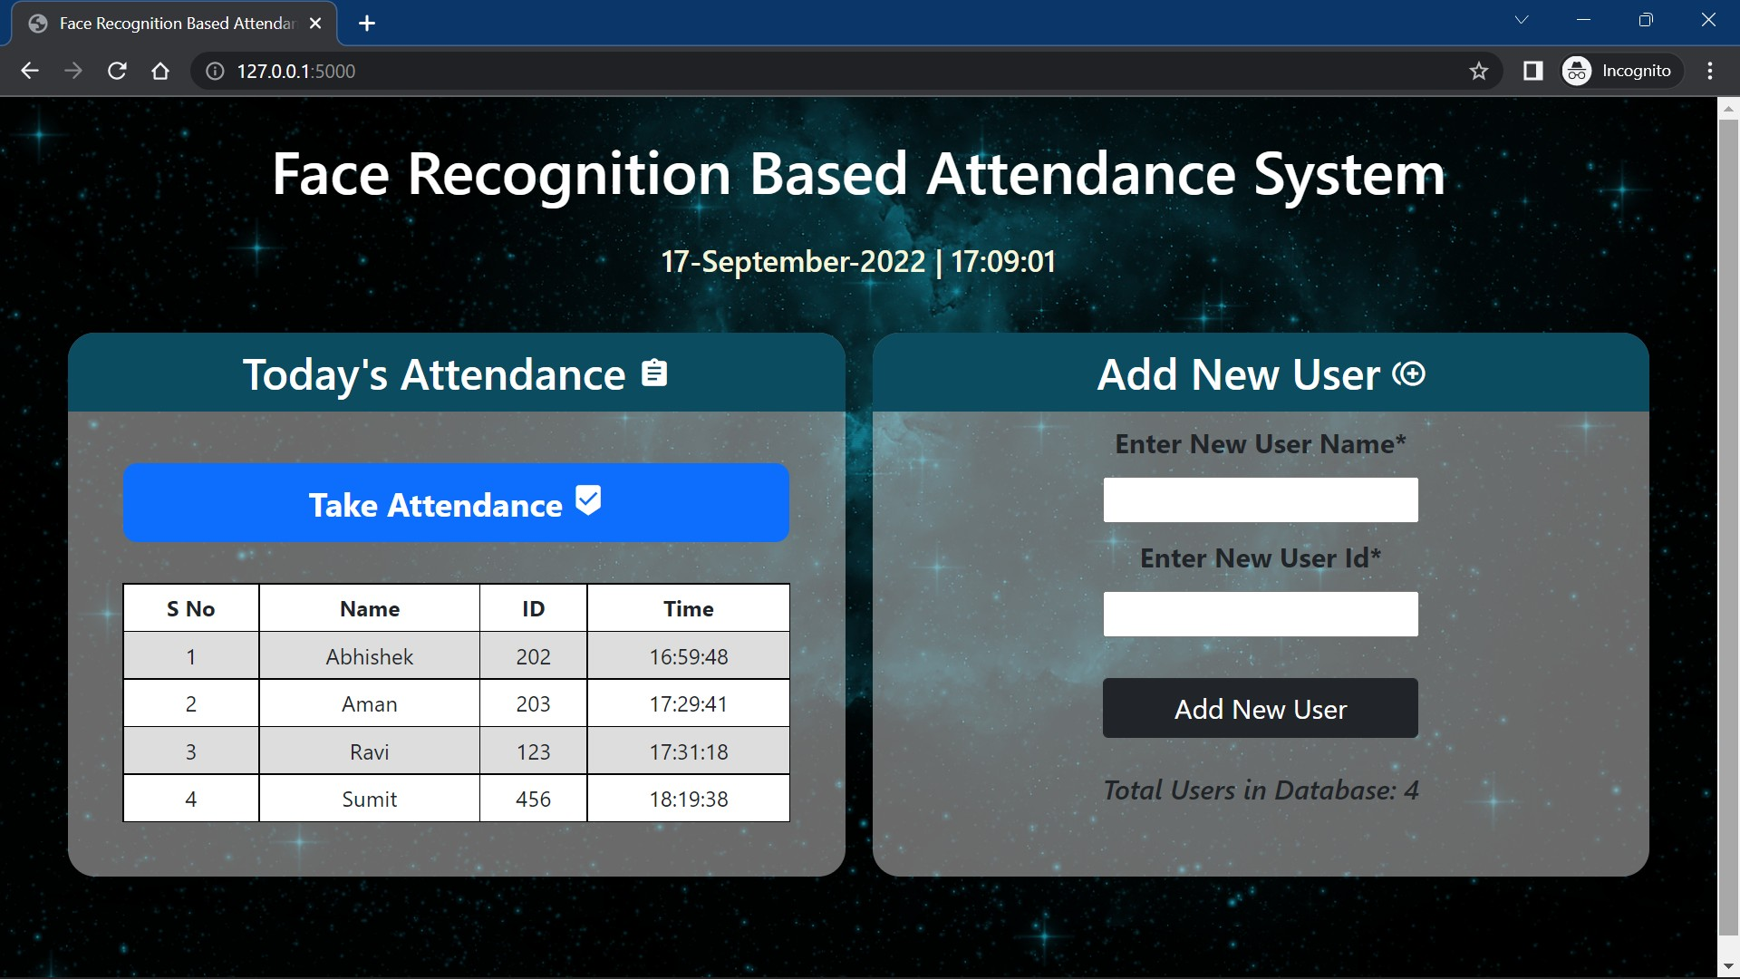

**4.3 Algorithm**

In order to obtain the attendance, positions and face images in lecture, we proposed the attendance management system based on face detection in the classroom lecture. The system estimates the attendance and positions of each student by continuous observation and recording. Current work is based on the method to obtain real-time face recognition by placing a camera at the entrance of the classroom. In this project we aim to build an Attendance marking system with the help of facial recognition owing the difficulty of the manual as well as other traditional means of attendance systems Building a solution that can be implemented in existing IoT set ups. Making the solution highly robust and scalable. A physically connected camera system will be used to acquire video footage from which frames containing facial information will be extracted. The acquired images will then be pre-processed first, then then fed to a facial detection algorithm for determination of facial features. The identification algorithm will then be used to determine the identity of the captured face with a pre-existing database.

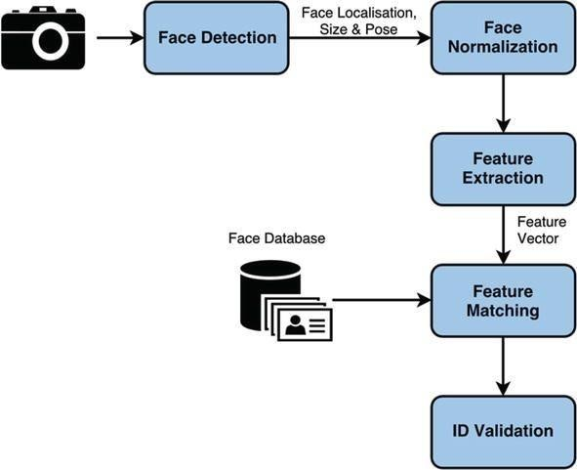

* This project uses the **Local Binary Patterns Histograms (LBPH)** in OpenCV to perform face recognition.
* **Local Binary Pattern** (LBP) is a simple yet very efficient texture operator which labels the pixels of an image by thresholding the neighborhood of each pixel and considers the result as a binary number.
* **Suppose we have a facial image in grayscale**,
* We can get part of this image as a window of 3x3 pixels.
* It can also be represented as a 3x3 matrix containing the intensity of each pixel (0~255).
* Then, we need to take the central value of the matrix to be used as the threshold.
* This value will be used to define the new values from the 8 neighbors.
* For each neighbor of the central value (threshold), we set a new binary value. We set 1 for values equal to or higher than the threshold and 0 for values lower than the threshold.
* Now, the matrix will contain only binary values (ignoring the central value). We need to concatenate each binary value from each position from the matrix line by line into a new binary value (e.g., 10001101). Note: some authors use other approaches to concatenate the binary values (e.g., clockwise direction), but the result will be the same.
* Then, we convert this binary value to a decimal value and set it to the central value of the matrix, which is a pixel from the original image.
* At the end of this procedure (LBP procedure), we have a new image which represents better the characteristics of the original image.

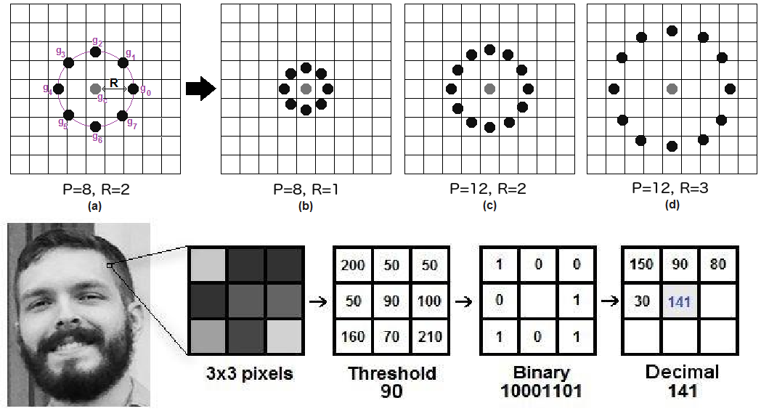

* + - As we have an image in grayscale, each histogram (from each grid) will contain only 256 positions (0~255) representing the occurrences of each pixel intensity.
    - Then, we need to concatenate each histogram to create a new and bigger histogram. Supposing we have 8x8 grids, we will have 8x8x256=16.384 positions in the final histogram. The final histogram represents the characteristics of the image original image.

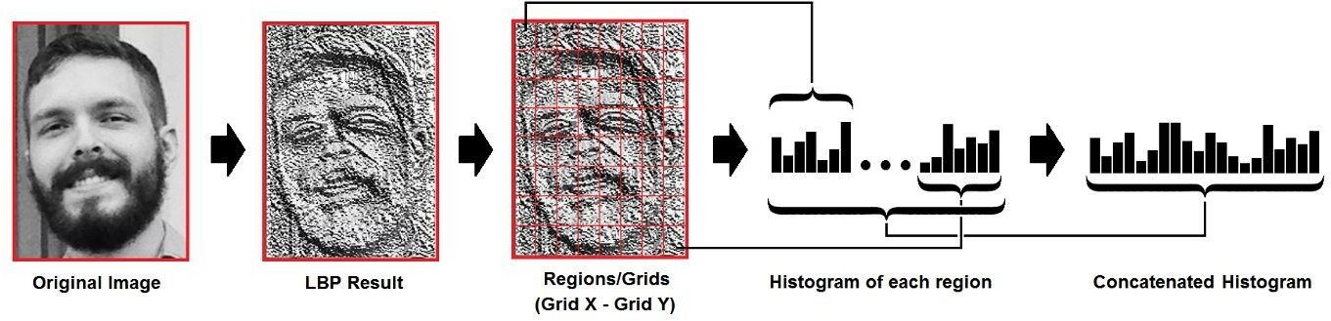

**K-Nearest Neighbor (KNN) Classifier Algorithm**

K Nearest Neighbour is a simple algorithm that stores all the available cases and classifies the new data or case based on a similarity measure. It is mostly used to classify a data point based on how its neighbors are classified. To solve this type of problem, we need a K-NN algorithm. With the help of K-NN, we can easily identify the category or class of a particular data.

**4.4 System Modeling**

**4.4.1 Data Flow Diagram**

**DFD 0**

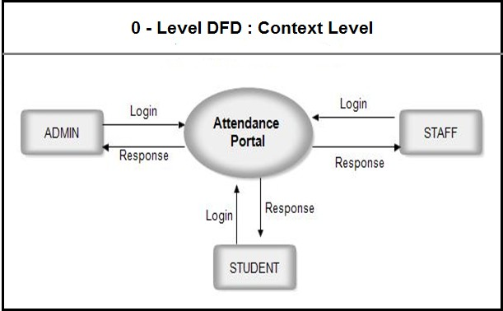

**DFD 1**

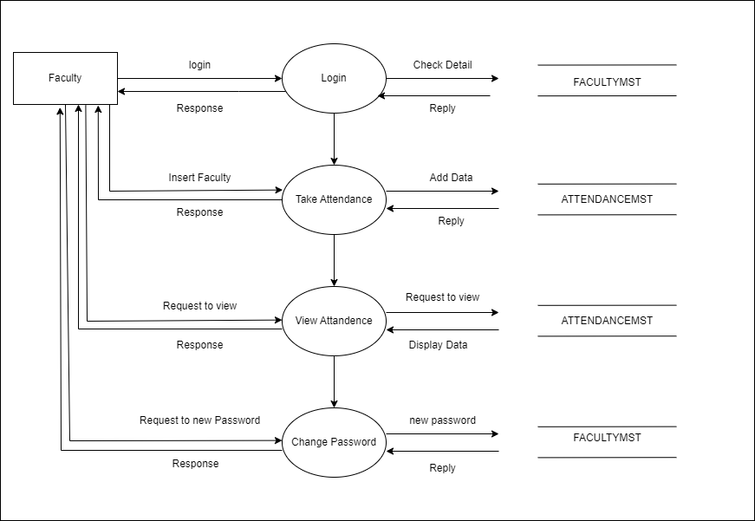

**4.4.2 Component Diagram**

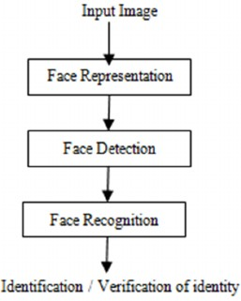

**4.4.3 Sequence Diagram**

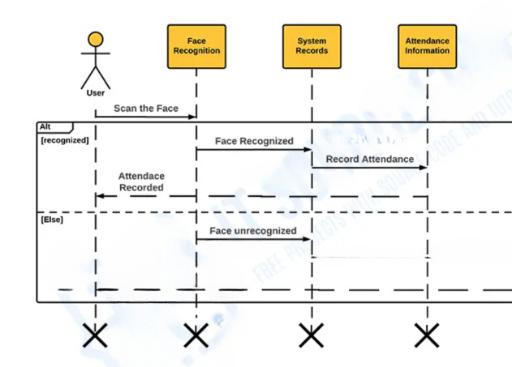

**4.4.4 Activity Diagram**

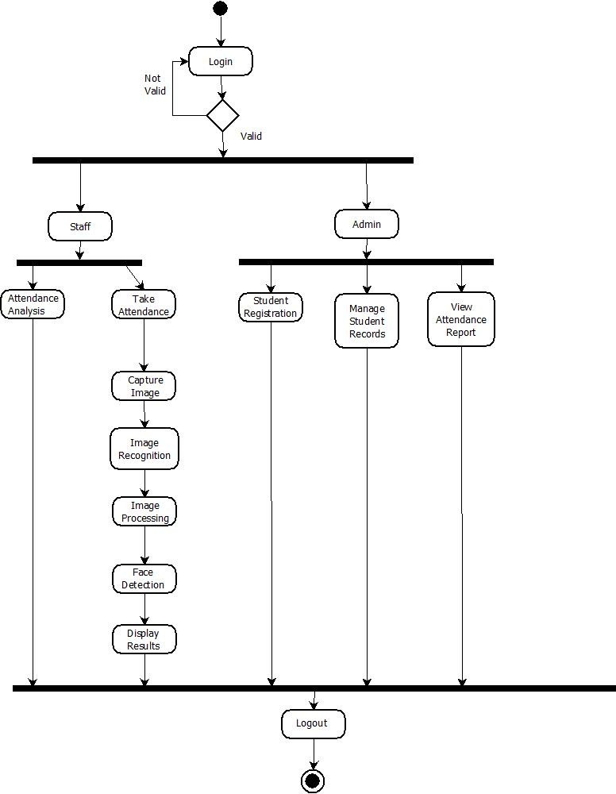

**Chapter 5**

**Implementation**

* 1. **Environment Setting for Running the Project**

Face Recognition libraries have other libraries as a pre- requisite to be installed prior to function. They are - dlib and cmake. For dlib to be installed it requires whl files for respective python versions. Currently, versions that support dlib are from python 3.7 and python 3.10. Dlib for python 3.11 is not currently available.

Operating System Support:

All of the new developments and algorithms in OpenCV run on the following desktop operating systems: Windows, Linux, macOS, FreeBSD, NetBSD, OpenBSD. OpenCV runs on the following mobile operating systems: Android, iOS, Maemo, BlackBerry 10. The user can get official releases from SourceForge or take the latest sources from GitHub. OpenCV uses CMake.

* 1. **Detailed Description of Methods**

1. Registration

Enter details**:** The student’s name and the unique id has to be entered for registering a particular student.

Capture image**:** 50 images of each student are captured for training purposes.

Click on the register button to add a student to the database. Once the student is registered, the count of students in the database automatically gets updated i.e., incremented. The images are stored in a folder assigned to it. Each image has a size less than 20kB.

1. Take Attendance

Click on the Take Attendance button in order to capture attendance.

Camera access permissions are given through the code. A screen with camera access pops up and the registered students can be identified. A frame that identifies the face is seen and the student’s name with the unique id appears on the screen.

The attendance sheet is updated in real time with student name, student id and titime at which the student entered the frame is added.

##### Face Detection

The image after background subtraction is used for face detection. In face detection the face of images are marked with the help of rectangle or circle. The face detected after background subtraction is accurate as compared to the face detected from an image which is not background subtracted.

##### Face Recognition

Face recognition process can be divided into three steps- prepare training data, train face recognizer, and prediction. Here training data will be the images present in the dataset. They will be assigned an integer label of the student it belongs to. These images are then used for face recognition. The algorithm will help to recognize the images based on the training dataset available.

Once the face is recognized, the student’s name along with the student id appears on the screen and also in the attendance sheet.

##### Attendance Updating:

After the face recognition process, the recognized faces will be marked as present in the excel sheet and the rest will be marked as absent and the list of absentees will be mailed to the respective faculties. Faculties will be updated with an attendance sheet at the end of lecture.

* 1. **Implementation Details**

Methodology:

LBPH (Local Binary Patterns Histograms) is a popular feature extraction algorithm used for face recognition tasks. It captures the local texture information of facial images and represents them as histograms. LBPH is a simple yet effective method that has shown promising results in various face recognition applications. Here is an overview of how LBPH works for face recognition:

**Image Preprocessing:**

The face images are preprocessed to enhance their quality and remove any noise or artifacts. This typically involves steps like face detection and alignment to ensure that the face region is properly aligned and normalized.

**Feature Extraction:**

In LBPH, the local texture information is extracted by comparing the intensity values of the pixels in a neighborhood around each pixel in the image. For each pixel, a binary code is generated based on whether its neighboring pixels have higher or lower intensity values compared to the central pixel. This binary code is referred to as the Local Binary Pattern (LBP) code.

**LBP Histogram Calculation:**

Once the LBP codes are computed for all pixels in the image, a histogram is constructed by counting the occurrence of different LBP patterns within the image. The histogram represents the distribution of different local texture patterns in the face image.

Training:

In the training phase, a set of face images with corresponding labels or identities is used to build a face recognition model. For each image, the LBPH algorithm computes the LBP histogram, which serves as a feature vector representing the face. These feature vectors are then stored in a database along with their corresponding labels.

Recognition:

To recognize a new or unseen face, the LBPH algorithm computes the LBP histogram for the test image. The similarity between the test image's feature vector and the feature vectors of the training images is calculated using distance metrics such as Euclidean distance or Chi-Square distance. The identity of the test image is determined based on the closest match in terms of the feature vector distances.

To improve its performance, LBPH can be combined with other techniques such as dimensionality reduction (e.g., PCA) or classification algorithms (e.g., k-nearest neighbors) to handle larger datasets or handle complex scenarios.

**Chapter 6**

**Integration and Testing**

**6.1 Description of Integration Modules**

|  |  |  |  |  |
| --- | --- | --- | --- | --- |
| **Sr. No** | **Module** | **Input** | **Output** | **Result** |
| 1. | Enter details | Student name and student id | Student is added to the database successfully | OK |
| 2. | Capture images | Capture student images through camera | Image is captured successfully | OK |
| 3. | Student detection | Live face capturing through camera | Frame around face formed successfully | OK |
| 4. | Student identification | Uploaded/ captured images | Student name and id is displayed on the screen, student identified successfully | OK |
| 5. | Taking attendance | Identified student | Attendance sheet made successfully | OK |

**6.2 Testing**

|  |  |  |  |  |  |
| --- | --- | --- | --- | --- | --- |
| **Sr.**  **No.** | **Module** | **Description** | **Expected Output** | **Actual Output** | **Result** |
| 1 | Enter Details | User has to enter the student name and unique id for registration | Student details entered successfully | Student details entered successfully | Pass |
| 2 | Capture Image | 50 images of student are captured through a camera | Image Acquisition is successful and student image is stored in database | Image Acquisition is successful and student image is stored in database | Pass |
| 3 | Student detection | After registration, student is detected | A face frame is formed with required PCA successfully | A face frame is formed with required PCA successfully | Pass |
| 4 | Student Identification | The algorithm has to identify the student which is shown through camera | Our system will identify accurate student and display name_id format in camera | Our system will identify accurate student and display name_id format in camera | Pass |
| 5 | Take Attendance | After the successful identification the student attendance is marked and displayed in excel sheet | Excel sheet having students attendance and time marked is shown | Excel sheet having students attendance and time marked is shown | Pass |

**Chapter 7**

**Future Scope**

**Future Scope**

Attendance systems using face recognition is promising, with several potential areas for further development and improvement. Here are some future directions and possibilities:

**Integration with Biometric Technologies:** Face recognition can be integrated with other biometric technologies such as fingerprint recognition or iris scanning to create a multi-modal biometric system.

**Real-time Monitoring and Analytics:** Future attendance systems can incorporate real-time monitoring and analytics capabilities. This includes features such as instant notifications for late or absent students, attendance tracking dashboards, and data analysis tools to identify attendance patterns, trends, and anomalies.

**Intelligent Attendance Management:** Advanced machine learning algorithms can be applied to attendance data to develop intelligent attendance management systems. These systems can predict student attendance based on historical data, identify factors influencing attendance, and provide personalized interventions or incentives to improve attendance rates.

**Facial Expression Analysis:** Beyond simple attendance tracking, future systems could explore facial expression analysis to gauge students' engagement levels and emotions in the classroom. This technology can provide insights into student behavior, help identify areas where additional support may be required, and contribute to a more interactive and engaging learning environment.

**Mobile and Cloud-Based Solutions:** Mobile applications can be developed to enable students, parents, and teachers to access attendance records and receive real-time updates on attendance status. Cloud-based solutions can facilitate seamless synchronization of attendance data across multiple devices and locations, improving accessibility and data management.

**Enhanced Security and Privacy:** This includes developing more robust anti-spoofing techniques to prevent unauthorized access, implementing encryption protocols to protect personal data, and ensuring compliance with privacy regulations.

**Scalability and Integration:** As attendance systems are implemented across educational institutions of varying sizes, future developments should focus on scalability and ease of integration. Efforts can be made to create scalable architectures that can handle large datasets and be seamlessly integrated with existing school management systems.

As technology continues to evolve, incorporating these future directions can lead to more intelligent, adaptive, and comprehensive attendance management solutions that benefit educational institutions and their stakeholders.

**Chapter 8**

**Applications**

An attendance system using face recognition technology has numerous applications across various domains. Here are some key areas where the application of such a system can be beneficial:

1. **Educational Institutions:**

Face recognition-based attendance systems can be implemented in schools, colleges, and universities to automate the attendance tracking process. It eliminates the need for manual attendance taking, reduces administrative burden, and provides accurate and real-time attendance data. Educational institutions can also use the system to track student attendance for regulatory compliance and generate attendance reports for parents and administrators.

1. **Corporate Organizations:**

Face recognition attendance systems can streamline attendance management in corporate settings. Employees can simply authenticate themselves by their faces, reducing the reliance on traditional methods like ID cards or biometric fingerprint systems. This improves efficiency, prevents buddy punching (where one employee punches in for another), and provides reliable attendance data for payroll processing and HR management.

1. **Events and Conferences:**

Face recognition attendance systems can be utilized in large-scale events, conferences, or seminars to track participant attendance. It allows for smooth and quick check-ins, eliminates the need for paper-based registration systems, and provides organizers with accurate attendance records for statistical analysis and post-event reporting.

1. **Access Control and Security:**

Face recognition technology can be integrated into access control systems to enhance security in restricted areas. By verifying an individual's face against a database, the system can grant or deny access based on authorized personnel. This can be valuable in high-security environments such as government buildings, research facilities, or data centers.

1. **Healthcare Facilities:**

Face recognition attendance systems can be employed in healthcare facilities, including hospitals and clinics, to monitor staff attendance. This ensures that the right personnel are available during critical times, helps track work hours, and simplifies payroll processing.

Additionally, it can help in managing visitors’ access to restricted areas within healthcare facilities.

1. **Public Transport Systems:**

Face recognition-based attendance systems can be implemented in public transport systems to monitor employee attendance, including drivers and conductors. It ensures that staff members are present on duty, provides accurate time records for shift management, and enables efficient scheduling and resource allocation.

**Chapter 9**

**Installation Guide and User Manual**

**9.1 Installation Guide**

* + 1. Install Python on your computer and install a Python IDE here, PyCharm.
    2. In your IDE, install all the necessary libraries required to run your code.
    3. The required libraries are: - cv2,
    4. flask , date , datetime, pandas, joblib , sklearn and the other pre-requisites for these libraries.
    5. In case your device does not have a web camera, make sure to install one externally.

**9.2 User Manual**

* + - 1. After the installation is complete, run the code and a url appears in the console.
      2. Click on the URL and it directs you to the web page to register the user and take attendance.

**To Register a student: -**

1. In the enter username section - enter the name of the student.
2. Enter the student-id i.e., roll number in the user id section.
3. Finally click on the add new user to add the user.
4. The camera opens and a frame appears around the face of the user.
5. 50 pictures of each student are clicked.
6. The pictures are then stored in a file with the name of each student and the id on your computer.
7. The count of the total users in the database gets incremented.

**To Take Attendance: -**

1. Click on the take attendance button.
2. The camera pops up.
3. If the student is registered, the name of the student and the id appears on the screen with a frame around the face.
4. The excel sheet for current attendance is stored in the folder named attendance.
5. The student’s name, the id and the attendance time all appear in the excel sheet.
6. A new attendance sheet is generated for each day.

**Chapter 10**

**Plagiarism Report**

**Report**

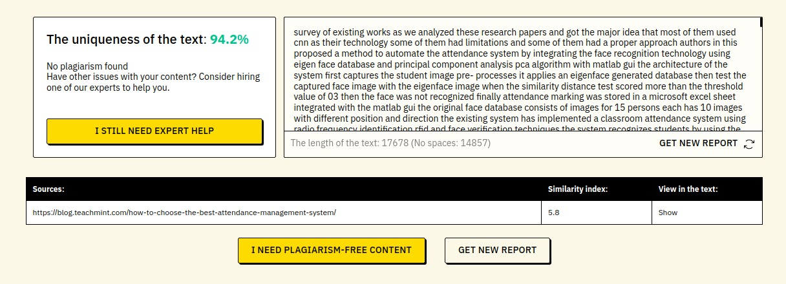

**Chapter 11**

**Ethics**

**Ethics**

**Creative Commons License**

Attribution-Share Alike 4.0 International (CC BY SA 4.0 This is human-readable summary of (and not a substitute for) the license.

You are free to:

**Share**- copy and redistribute the material in any medium or format.

**Adapt**- remix, transform, and build upon the material for any purpose, even commercially. The licensor cannot revoke these freedoms if you follow the license terms.

**Using the following terms:**

Attribution you must give appropriate credit, provide a link to the license, and indicate if changes were made. You may do so in any responsible manner, but not in any way that suggests the licensor endorses you or your use.

**Share Alike**- you remix, transform, and build upon the material for any purpose, you must distribute your contributions under the same license as the original.

**No additional restrictions**- You must apply legal terms or technological measures that l legally restrict others from doing anything the license permits.

**Notices:**

You do not have to comply with the license for elements of the material in the public domain or where your use is permitted by an application exception or limitation. No warranties are given. The license may not give you all the permissions necessary for your intended use. For example, other rights such as publicity, privacy, or moral rights may limit hoe you use the material.

**Ethical Practices for CSE Students:**

**As Computer Sc. & Engineering** student**,** I believe it is unethical to:

* + - Take credit for someone else's work.
    - Hire someone to write an assignment.
    - Purchase or submit a research or term paper from the internet to a class as one's own work.
    - Cheat on a graded assignment
    - Cheat on an exam
    - Plagiarize other people's work without citing or referencing the work.
    - Add the name of a non-contributing person as an author in project/research study.
    - Copy and paste material found on the Internet for an assignment without acknowledging the authors of the material.
    - Deliberately provide inaccurate references for a project or research study
    - Knowingly permit student work done by one student to be submitted by another student.
    - Surf the internet for personal interest and non-class related purposes during classes.
    - Make a copy of software for personal or commercial use.
    - Make a copy of software for a friend.
    - Loan CDs of software to friends
    - Download pirated software from the internet.
    - Distribute pirated software from the internet.
    - Buy software with a single user license and then install it on multiple computers.
    - Share a pirated copy of software.
    - Install a pirated copy of software.

**Chapter 12**

**References**

**References**

[1] X. Zhao and C. Wei, "A real-time face recognition system based on the improved LBPH algorithm," 2017. Available: [*https://ieeexplore.ieee.org/stamp/stamp.jsp?tp=&arnumber=8124508&isnumber=8124489*](https://ieeexplore.ieee.org/stamp/stamp.jsp?tp=&arnumber=8124508&isnumber=8124489)

[2] H. Filali, J. Riffi, A. Mohamed, M. Hamid Tairi, "Multiple face detection based on machine learning," in 2018 IEEE, ISBN 978-1-5386-4396-9/18/$31.00.

[3] K. He, X. Zhang, S. Ren, and J. Sun, "Deep Residual Learning for Image Recognition," in 2016 IEEE Conference on Computer Vision and Pattern Recognition (CVPR), Las Vegas, NV, 2016, pp. 770-778.

[4] N. Dalal and B. Triggs, "Histograms of oriented gradients for human detection," in 2005 IEEE Computer Society Conference on Computer Vision and Pattern Recognition (CVPR'05), San Diego, CA, USA, 2005, pp. 886-893 vol. 1.

[5] Viola, P., & Jones, M. (2001). Rapid object detection using a boosted cascade of simple features. In Proceedings of the 2001 IEEE computer society conference on computer vision and pattern recognition (CVPR 2001) (Vol. 1, pp. I-I). IEEE.

[6] J. Joseph and K. P. Zacharia, "Automatic Attendance Management System Using Face Recognition," International Journal of Science and Research (IJSR), ISSN 2319-7064, 2013.

[7] Y. Yorozu, M. Hirano, K. Oka, and Y. Tagawa, "Electron spectroscopy studies on magneto-optical media and plastic substrate interface," IEEE Transl. J. Magn. Japan, vol. 2, pp. 740-741, Aug. 1987 [Digests 9th Annual Conf. Magnetics Japan, p. 301, 1982].

[8]Bhattacharjee, D., Dey, S., & Bhattacharjee, D. P. (2017). Real-time face recognition using eigenfaces and fisherfaces. International Journal of Image, Graphics and Signal Processing, 9(10), 1-11.

[9]Viola, P., Jones, M. (2001). Robust real-time object detection. International Journal of Computer Vision, 47(2-3), 167-187.

[10] Cen, K. (2017). Study of Viola-Jones real-time face detector [PDF file]. Retrieved from Stanford University website: [*http://web.stanford.edu*](http://web.stanford.edu/)

[11]"Statistical Classification." (2017). In Wikipedia. Retrieved August 1, 2017, from [*https://en.wikipedia.org/wiki/Statistical_classification*](https://en.wikipedia.org/wiki/Statistical_classification)

[12]"Face Detection." (2017). In Wikipedia. Retrieved August 1, 2017, from [*https://en.wikipedia.org/wiki/Face_detection*](https://en.wikipedia.org/wiki/Face_detection)

[13]"Machine Learning is Fun! Part 4: Modern Face Recognition with Deep Learning." (2017). In Medium. Retrieved August 1, 2017, from [*https://medium.com*](https://medium.com)

[14] Nehemiah, A. (2017). Face Recognition with MATLAB [Video]. Retrieved from MathWorks website:[*https://www.mathworks.com*](https://www.mathworks.com/)